Communication Management Plan
LitPath AI: Smart Pathfinder for Theses and Dissertations

Asia Pacific College
3 Humabon, Magallanes
Makati City, Metro Manila 1232

April 1, 2026

Table of Contents
Introduction 3
Communications Management Approach 3
Communications Management Constraints 4
Stakeholder Communication Requirements 4
Roles 5
Project Team Directory 6
Communication Methods and Technologies 7
Communications Matrix 8
Communication Flowchart 9
Guidelines for Meetings 11
Communication Standards 12
Communication Escalation Process 12
Glossary of Communication Terminology 13

Introduction
This Communications Management Plan sets the communications framework for the LitPath AI project. It will serve as a guide for communications throughout the life of the project from its current development phase through final deployment in June–July 2026 and will be updated as communication needs change. This plan identifies and defines the roles of all persons involved in the project. It includes a communications matrix which maps the communication requirements of this project, an in-depth guide for conducting meetings, and a project team directory providing contact information for all stakeholders directly involved in the project.

Communications Management Approach
Effective communication is one of the most critical factors in the success of the LitPath AI project. Given that the project involves multiple stakeholders including the DOST-STII client and sponsor, the development team, the PBL instructor, and end users, considerable thought has been given to how communications will be managed across all phases of the project.
The Project Manager, Tracie Tomon, is authorized to interface with management, negotiate for resources, and communicate with all stakeholders to ensure the timely and successful completion of LitPath AI. The Project Manager will take a proactive role in ensuring that all communications are clear, timely, and aligned with the project's objectives and milestone schedule.

Given the academic and client-facing nature of this project, communications will be structured around two key tracks:
- Internal team communications — handled through weekly team meetings, sprint boards in OpenProject, and a group messaging platform (Messenger or Microsoft Teams) for day-to-day coordination among the four HecTech members.
- External stakeholder communications — handled through Viber, scheduled client meetings with DOST-STII, and documentation submissions to the PBL instructor aligned with milestone completion dates.

By maintaining this dual-track approach, the team ensures that development progress stays transparent and that stakeholders such as the Project Sponsor, Khasian Eunice Romulo, remain informed without being burdened by operational-level detail.

The communications requirements are documented in the Communications Matrix in this plan, which serves as the definitive guide for what to communicate, who communicates it, how frequently, and to whom. As with any project, updates or changes to this plan may be necessary as the project progresses, particularly with upcoming milestones such as the April 2026 internal testing, May–June 2026 usability testing, and the June–July 2026 final deployment. Any changes to this plan will be reviewed and approved by the Project Sponsor before taking effect, and the updated plan will be redistributed to the project team and all stakeholders.

Communications Management Constraints
All LitPath AI project communication activities will occur within the project's approved schedule and resource allocations. Because LitPath AI does not operate with a formal standing budget, the primary constraints are time and the availability of the four-person HecTech development team. AI/LLM API costs are anticipated and will be shouldered by DOST-STII, while system hosting is managed internally by the team using on-premises infrastructure.
The Project Manager is responsible for ensuring all communication activities are carried out by team members without exceeding available time or resources. The project team must exercise care in handling confidential information related to this project, including system architecture details, DOST-STII database structures, and user data. Distribution of such information is strictly controlled and must be authorized by the Project Manager or Project Sponsor prior to external release.
All formal project communications will use the standard templates and formats established by the team. Only the Project Manager or the Project Sponsor may authorize the distribution of sensitive information related to the DOST-STII library database, system architecture, or user data. The Project Manager is responsible for obtaining this approval before any such information is distributed externally.

Stakeholder Communication Requirements
As part of identifying all project stakeholders, the Project Manager will communicate with each stakeholder to determine their preferred frequency and method of communication. This feedback will be maintained by the Project Manager in the project's Stakeholder Register. Standard project communications will occur in accordance with the Communication Matrix; however, depending on the identified stakeholder communication requirements, individual communication is acceptable and within the constraints outlined for this project.
In addition to identifying communication preferences, stakeholder communication requirements must identify the project's communication channels and ensure that stakeholders have access to these channels. If project information is communicated via secure means or through internal team resources, all stakeholders, internal and external, must have the necessary access to receive project communications.
Once all stakeholders have been identified and communication requirements are established, the project team will maintain this information in the project's Stakeholder Register and use this, along with the project communication matrix, as the basis for all communications.

Roles

Project Sponsor
Khasian Eunice Romulo
Science Research Specialist II / Unit Head, Digital Information and Processing Delivery Unit, DOST-STII. She authorized the project by signing the Project Charter and is the primary client. As sponsor, she is responsible for approving changes to scope and milestone dates, and for shouldering cloud and AI/LLM operational costs. Communications to the sponsor should be presented in summary format unless she requests more detail.

Project Manager
Tracie Tomon
The Project Manager is authorized to interface with management, negotiate for resources, delegate responsibilities, and communicate with all stakeholders. She is responsible for developing the project plan, monitoring schedule and scope, assigning tasks, overseeing system integration, testing, and documentation, and organizing final outputs for defense and presentation. The Project Manager is the primary communicator for the project.

Key Stakeholders
Key Stakeholders for LitPath AI include the PBL instructor who evaluates milestone deliverables, the DOST-STII Library staff who will use and maintain the system, and student researchers and professionals who are the primary end users of the platform. These stakeholders require timely updates on milestone completions, usability testing results, and deployment readiness, and their feedback is incorporated into the project's continuous improvement cycle.

Change Control Board
The Change Control Board for LitPath AI consists of the Project Sponsor (Khasian Eunice Romulo) and the Project Manager (Tracie Tomon). This board reviews requests for changes to project scope, technical architecture, or milestone dates. Technical design documents, user impact analyses, and revised implementation strategies are the types of communication this group requires. No change may be implemented without the board's approval.

Customer
The DOST-STII Library is the customer and will be involved in reviewing prototypes, approving design stages, and formally accepting the final deliverables. The customer will be kept informed of project status, including any potential impacts to the schedule or the system itself. Communications with the customer are primarily handled through Viber and scheduled face-to-face or online meetings.

Project Team
The Project Team is comprised of the four HecTech members responsible for all design, development, testing, and documentation work packages: Tracie Tomon, Charijoy Cempron, Jenine Elaine Dulay, and Joshua Sta Ana. The team requires detailed communication through daily interactions, weekly team meetings, and sprint board updates in OpenProject. Each member is expected to keep task statuses current and flag blockers immediately to the Project Manager.

Steering Committee
The Steering Committee for this project is represented by the PBL instructor and DOST-STII management, who provide strategic oversight and ensure that the project's direction aligns with academic requirements and institutional goals. The Steering Committee requires communication on matters that will change the scope of the project and its deliverables and will be updated at key milestone checkpoints.

Technical Lead
Joshua Sta Ana
Responsible for ensuring all technical aspects of the project are addressed, including the AI search engine architecture, system turnover with the DOST-STII OPAC, and technical documentation. Requires close coordination with the Project Manager and the rest of the development team.

Project Team Directory
The following table presents contact information for all people identified in this communications management plan. The email addresses and phone numbers on this table will be used to communicate with these people.

Role | Name | Title | Organization/ Department | Email
Project Sponsor | Khasian Eunice Romulo | Science Research Specialist II / Unit Head | DOST-STII | (via Viber)
Project Manager | Tracie Tomon | Group Leader | HecTech / Asia Pacific College | tctomon@student.apc.edu.ph
Project Team | Charijoy Cempron | Developer | HecTech / Asia Pacific College | ctcempron@student.apc.edu.ph
Project Team | Jenine Elaine Dulay | Developer | HecTech / Asia Pacific College | jcdulay@student.apc.edu.ph
Project Team | Joshua Sta. Ana | Developer | HecTech / Asia Pacific College | jtstaana2@student.apc.edu.ph
PBL Instructor | Jose Eugenio L. Quesada | Instructor | Asia Pacific College | jlquesada@apc.edu.ph

Communication Methods and Technologies
The project team will determine the communication methods and technologies based on several factors including stakeholder communication requirements, available technologies (internal and external), and the needs of the LitPath AI project.
HecTech maintains a SharePoint platform which all project members use to provide updates, archive various reports, and conduct project communications. This platform enables the Project Sponsor and DOST-STII staff, as well as other stakeholders with compatible technology, to access project data and communications at any point in time. SharePoint also provides the ability for stakeholders and project team members to collaborate on project work and communication.
For stakeholders who do not have the ability to access SharePoint, relevant documents will be shared via Viber or a direct SharePoint link by the Project Manager. The Project Manager is responsible for ensuring all project communications and documentation are uploaded to SharePoint and always kept current.
HecTech uses OpenProject as its primary project management platform. All project team members are responsible for developing, maintaining, and communicating schedules, work packages, backlogs, and sprint progress using this platform. The Gantt chart is the preferred format for communicating schedules to stakeholders. The project schedule will be maintained on both OpenProject and the SharePoint platform.
All project communication and documentation, in addition to being maintained on SharePoint and OpenProject, will be archived in the HecTech shared project directory.

The following communication tools are used by the project team:
- Face-to-face meetings — for client meetings with DOST-STII, design reviews, and formal milestone check-ins.
- Video conferencing (MS Teams) — for remote team meetings and instructor check-ins when in-person is not possible.
- Viber — for formal communications with the Project Sponsor and DOST-STII staff; used for distributing reports, documentation, and milestone updates.
- Microsoft Teams — for informal day-to-day communication among the four HecTech team members.

Communications Matrix
The following table identifies the communications requirements for this project.

Communication Type | Objective of Communication | Medium | Frequency | Audience | Owner | Deliverable | Format
Sprint Planning | Define sprint goals, scope, and tasks for the team | Face to face or Microsoft Teams | Once per sprint | Project Team | Project Manager | Sprint Plan, Meeting Minutes | Video recording stored on Microsoft Teams channel and SharePoint
Daily Stand-up | Provide daily progress updates and identify blockers | Face to face or Microsoft Teams | Daily during active sprints | Project Team | Project Manager | Stand-up Meeting Minutes | Video recording stored on Microsoft Teams channel and SharePoint
Backlog Refinement | Review and update backlog items for upcoming work | Face to face or Microsoft Teams | Once per sprint | Project Technical Staff | Project Manager | Updated Product Backlog | Video recording stored on Microsoft Teams channel, OpenProject, and SharePoint
Sprint Review | Present completed work and gather feedback from stakeholders | Face to face or Microsoft Teams | Once per sprint | Project Team, Project Adviser, Client | Project Manager | Sprint Demo, Meeting Minutes | Video recording stored on Microsoft Teams channel and SharePoint
Sprint Retrospective | Evaluate sprint performance and identify improvements | Face to face or Microsoft Teams | Once per sprint | Project Team | Project Manager | Retrospective Meeting Minutes | Video recording stored on Microsoft Teams channel and SharePoint
Project Status Reports | Report on overall project progress, issues, and updates | Face to face or Microsoft Teams | Per sprint | Project Sponsor, Project Adviser | Project Manager | Project Status Report | Soft copy sent via Viber
Client Coordination Meeting | Discuss project progress and align with client expectations | Face to face or Microsoft Teams or Viber | As needed | Project Manager, Client | Project Manager | Meeting Minutes | Soft copy archived in SharePoint

Communication Flowchart
The communication flowchart below was created to aid in project communication. This flowchart provides a framework for the project team to follow for this project. However, there may be occasions or situations which fall outside of the communication flowchart where additional clarification is necessary. In these situations, the Project Manager is responsible for discussing communication with the Project Sponsor and deciding on how to proceed.

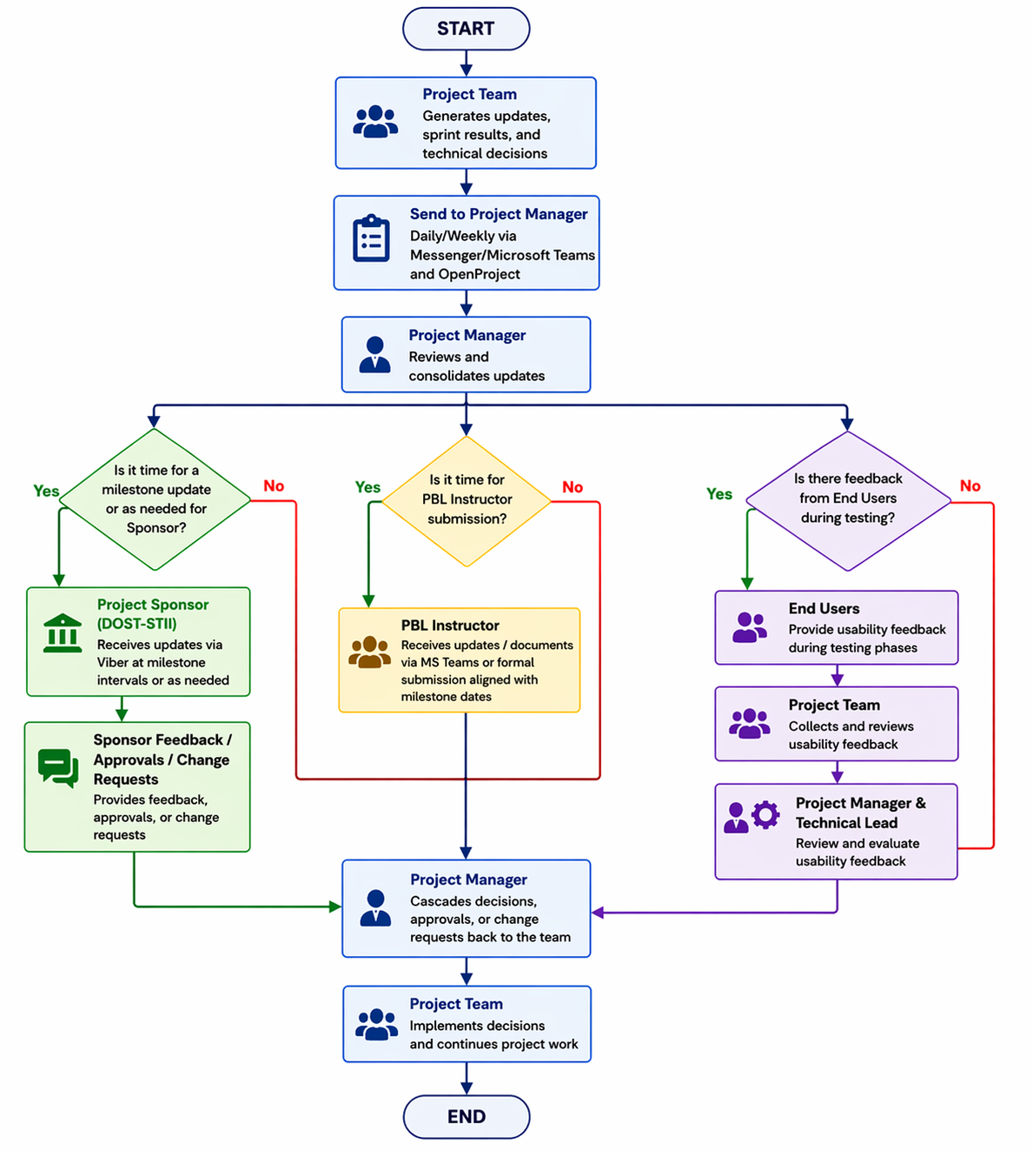

Guidelines for Meetings

Meeting Agenda
Meeting Agenda will be distributed 5 business days in advance of the meeting. The agenda should identify the presenter for each topic along with a time limit for that topic. The first item on the agenda should be a review of action items from the previous meeting.

Meeting Minutes
Meeting minutes will be distributed within 2 business days following the meeting. Meeting minutes will include the status of all items on the agenda along with new action items and the Parking Lot list.

Action Items
Action Items are recorded in both the meeting agenda and minutes. Action items will include both the action items along with the owner of the action item. Meetings will start with a review of the status of all action items from previous meetings and end with a review of all new action items resulting from the meeting. The review of the new action items will include identifying the owner of each action item.

Meeting Chairperson
The Chairperson is responsible for distributing the meeting agenda, facilitating the meeting and distributing the meeting minutes. The Chairperson will ensure that the meeting starts and ends on time and that all presenters adhere to their allocated time frames.

Note Taker
The Note Taker is responsible for documenting the status of all meeting items, maintaining a Parking Lot item list and taking notes of anything else of importance during the meeting. The Note Taker will give a copy of their notes to the Chairperson at the end of the meeting as the Chairperson will use the notes to create the Meeting Minutes.

Timekeeper
The Timekeeper is responsible for helping the facilitator adhere to the time limits set in the meeting agenda. The Timekeeper will let the presenter know when they are approaching the end of their allocated time. Typically, a quick hand signal to the presenter indicating how many minutes remaining for the topic is sufficient.

Parking Lot
The Parking Lot is a tool used by the facilitator to record and defer items which aren’t on the meeting agenda; however, it merits further discussion later or through another forum.
A parking lot record should identify the owner of the item as that person will be responsible for ensuring follow-up. The Parking Lot list is to be included in the meeting minutes.

Communication Standards
Standardization helps simplify the complexities of project management communications and ensures that all team members and stakeholders have a consistent understanding of what to expect.
For this project, HecTech will utilize standard templates and formats for all formal project communications. Formal project communications are detailed in the project's communication matrix and include:

- Kickoff Meeting — HecTech will use standard templates for meeting agenda and meeting minutes. Any slides presented will use the HecTech standard slideshow template.
- Weekly Team Meetings — HecTech will use standard templates for meeting agenda and meeting minutes. Any slides presented will use the HecTech standard slideshow template.
- Technical Design Meetings — HecTech will use standard templates for meeting agenda and meeting minutes. Any slides presented will use the HecTech standard slideshow template.
- Milestone Status Updates / Client Review Meetings — HecTech will use standard templates for meeting agenda and meeting minutes. Status reports and presentations will use the HecTech standard slideshow and report templates.
- Project Status Reports — HecTech will use the standard project status report document, available on the SharePoint shared drive, to provide project status updates to the sponsor and instructor.
- Informal project communications — such as day-to-day messages via Messenger or Discord — should be professional and effective but do not require a standard template or format.
All documents will follow the HecTech file naming convention and will be archived on the SharePoint platform. Version control will be maintained by the Project Manager.

Communication Escalation Process
As issues or complications arise regarding project communications, it may become necessary to escalate if a resolution cannot be achieved within the project team. While escalations are a normal part of project management, there must be a documented process that defines how those escalations will take place.

Efficient and timely communication is the key to successful project completion. As such, it is imperative that any disputes, conflicts, or discrepancies regarding project communications are resolved in a way that is conducive to maintaining the project schedule, ensuring the correct communications are distributed, and preventing ongoing difficulties. HecTech will use the following escalation model to provide a framework for resolving communication issues. The table below defines the priority levels, decision authorities, and timeframes for resolution.

Priority | Definition | Decision Authority | Timeframe for Resolution
Priority 1 | Major impact to project or business operations. If not resolved quickly there will be a significant adverse impact on revenue and/or schedule. | Project Sponsor | Within 4 hours
Priority 2 | Medium impact on project or business operations which may result in some adverse impact to revenue and/or schedule. | Project Sponsor | Within one business day
Priority 3 | Slight impact may cause some minor scheduling difficulties with the project but no impact on business operations or revenue. | Project Manager | Within two business days
Priority 4 | It has an insignificant impact on the project but there may be a better solution. | Project Manager | Work continues and any recommendations are submitted via the project change control process

** NOTE: Any communication including sensitive and/or confidential information, particularly information related to the DOST-STII library database, system architecture, or user data will require escalation to the Project Sponsor for approval prior to external distribution.

Glossary of Communication Terminology
Term | Definition
Communication | The effective sending and receiving of information. Ideally, the information received should match the information sent. It is the responsibility of the sender to ensure this takes place.
Stakeholder | Individuals or groups involved in the project or whose interests may be affected by the project’s execution or outcome.
Communications Management Plan | Portion of the overall Project Management Plan which details how project communications will be conducted, who will participate in communications, frequency of communications, and methods of communications.
Escalation | The process which details how conflicts and issues will be passed up the management chain for resolution as well as the timeframe to achieve resolution.
Communications Matrix | A table that maps each type of project communication to its objective, medium, frequency, audience, owner, and deliverable format.
Sprint Board | The visual task management board in OpenProject used by the HecTech team to track work packages, backlogs, and sprint progress.
Milestone | A significant scheduled checkpoint in the project that marks the completion of a major phase or deliverable.

Sponsor Acceptance

Approved by the Project Sponsor:

Date: April 1, 2026
Khasian Eunice Romulo
Science Research Specialist II / Unit Head
(Digital Information and Processing Delivery Unit)

